Identifying 10-Year Risk Factors of Stroke in Framingham Heart Study
Marshall Roll
Introduction

Tables and Figures
Characteristic | Overall N = 4,402¹ | Female N = 2,472¹ | Male N = 1,930¹
Covariates
Age | 49.88 (8.66) | 49.99 (8.63) | 49.73 (8.71)
Systolic BP | 132.76 (22.32) | 133.66 (24.33) | 131.60 (19.40)
Diastolic BP | 83.03 (12.01) | 82.53 (12.41) | 83.66 (11.44)
High Systolic BP (≥160) | 524 (12%) | 353 (14%) | 171 (8.9%)
Total Cholesterol, mg/dL | 237.01 (44.65) | 239.70 (46.19) | 233.62 (42.39)
(Missing) | 52 | 45 | 7
Smoker | 2,169 (49%) | 1,001 (40%) | 1,168 (61%)
BMI | 25.83 (4.08) | 25.57 (4.52) | 26.17 (3.40)
(Missing) | 17 | 13 | 4
Diabetes | 119 (2.7%) | 60 (2.4%) | 59 (3.1%)
Blood Pressure Medication | 136 (3.1%) | 96 (3.9%) | 40 (2.1%)
(Missing) | 60 | 38 | 22
Coronary Heart Disease | 187 (4.2%) | 67 (2.7%) | 120 (6.2%)
Past MI | 82 (1.9%) | 14 (0.6%) | 68 (3.5%)
Outcomes
10-year Stroke | 383 (8.7%) | 204 (8.3%) | 179 (9.3%)
10-year MI | 450 (10%) | 132 (5.3%) | 318 (16%)
10-year Death | 1,525 (35%) | 694 (28%) | 831 (43%)
Follow-up Time, years | 9.51 (1.67) | 9.60 (1.54) | 9.40 (1.82)
¹Mean (SD); n (%)
Table 1: Baseline characteristics of study cohort and outcomes stratified by sex.

10-Year Stroke Probability, Male
Risk Profile | Age 40 | Age 50 | Age 60
No Risk Factors | 4.00% (2.70%, 5.28%) | 6.73% (5.09%, 8.34%) | 11.23% (8.44%, 13.94%)
High SBP (≥160) | 7.62% (4.97%, 10.19%) | 12.66% (9.52%, 15.70%) | 20.66% (16.01%, 25.05%)
Diabetes | 9.94% (4.97%, 14.66%) | 16.39% (9.32%, 22.90%) | 26.35% (15.58%, 35.75%)
High SBP + Diabetes | 18.41% (9.20%, 26.69%) | 29.37% (17.30%, 39.67%) | 44.79% (28.65%, 57.28%)
Smoker | 6.54% (4.91%, 8.14%) | 10.92% (9.10%, 12.69%) | 17.92% (14.33%, 21.36%)
Table 2: Estimated 10-year stroke probability across risk profiles for males. 95% confidence intervals calculated with log-transformation.

10-Year Stroke Probability, Female
Risk Profile | Age 40 | Age 50 | Age 60
No Risk Factors | 3.09% (2.02%, 4.14%) | 5.58% (4.37%, 6.77%) | 9.98% (7.81%, 12.11%)
High SBP (≥160) | 4.64% (2.87%, 6.38%) | 8.33% (6.41%, 10.21%) | 14.72% (12.00%, 17.35%)
Diabetes | 6.71% (2.64%, 10.62%) | 11.94% (5.61%, 17.85%) | 20.77% (10.12%, 30.16%)
High SBP + Diabetes | 9.98% (3.85%, 15.73%) | 17.52% (8.47%, 25.67%) | 29.71% (15.67%, 41.42%)
Smoker | 4.29% (2.93%, 5.63%) | 7.71% (5.98%, 9.40%) | 13.65% (10.02%, 17.14%)
Table 3: Estimated 10-year stroke probability across risk profiles for females. 95% confidence intervals calculated with log-transformation.

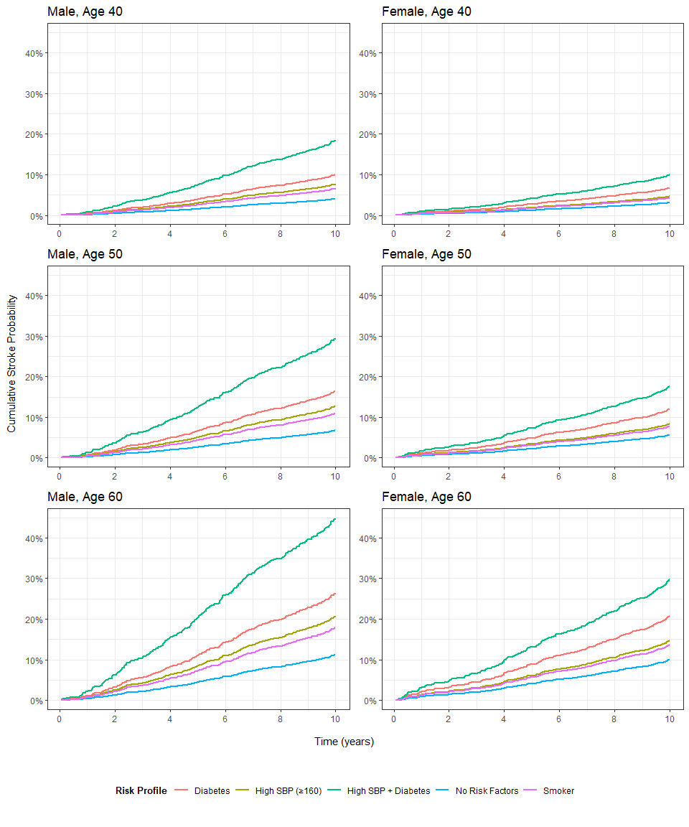
Figure 1: Estimated 10-year cumulative stroke probability across five risk profiles of interest, organized by age and sex.

 | Period
Characteristic | 1 N = 3,197¹ | 2 N = 3,197¹ | 3 N = 3,197¹
Systolic BP | 130.12 (20.07) | 135.64 (21.59) | 140.19 (22.93)
Total Cholesterol (mg/dL) | 235.41 (44.01) | 249.97 (44.93) | 236.56 (44.39)
(Missing) | 32 | 109 | 210
Smoker | 1,522 (48%) | 1,391 (44%) | 1,094 (34%)
BMI | 25.74 (3.97) | 25.86 (4.04) | 25.90 (4.08)
(Missing) | 7 | 9 | 14
Diabetes | 58 (1.8%) | 105 (3.3%) | 250 (7.8%)
Blood Pressure Medication | 77 (2.4%) | 275 (8.8%) | 414 (15%)
(Missing) | 40 | 75 | 437
Coronary Heart Disease | 74 (2.3%) | 178 (5.6%) | 350 (11%)
¹Mean (SD); n (%)
²Kruskal-Wallis rank sum test; Pearson's Chi-squared test
Table 4: Distribution of key covariates across three study periods, occurring approximately six years apart between 1956 and 1968 among cases with at least one measurement per period.

Appendix
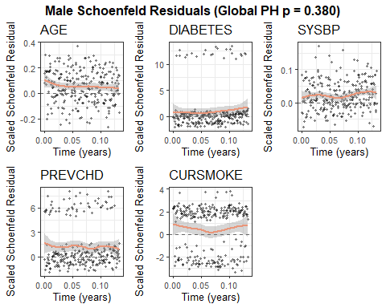
Supplemental Figure 1: Schoenfeld residuals across covariates included in final survival model for males, indicating moderately strong adherence to Cox PH assumptions. Global test yields p > 0.05, indicating no evidence that proportional hazard assumptions are violated.

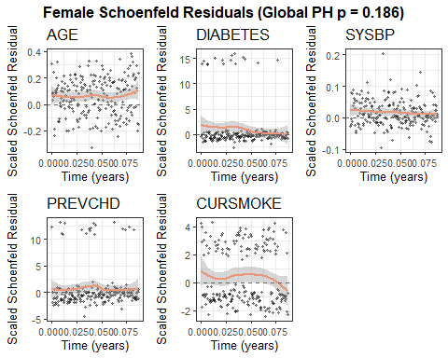
Supplemental Figure 2: Schoenfeld residuals across covariates included in final survival model for females, indicating moderate adherence to Cox PH assumptions, with a possible violation in the smoker variable. Global test yields p > 0.05, indicating no evidence that proportional hazard assumptions are violated.

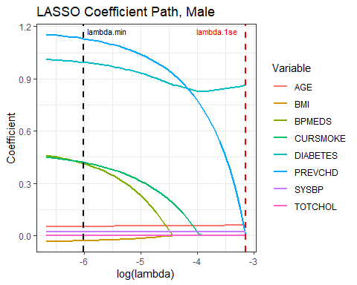
Supplemental Figure 3: LASSO coefficient path across differing lambda values, with lambda.min indicating the lambda value minimizing mean cross-validated error and lambda.1se indicating the largest lambda value within 1 standard error of the minimum for male model. Lambda was selected as an interim value between lambda.min and lambda.1se where several predictors with large signals are retained in the final model.

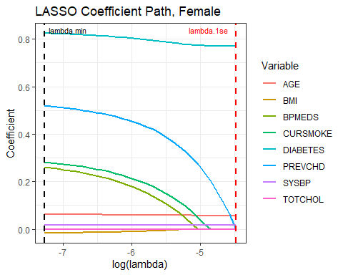
Supplemental Figure 4: LASSO coefficient path across differing lambda values, with lambda.min indicating the lambda value minimizing mean cross-validated error and lambda.1se indicating the largest lambda value within 1 standard error of the minimum for female model. Lambda was selected as an interim value between lambda.min and lambda.1se where several predictors with large signals are retained in the final model.

